Lab 9 Report
Content
1. Knative Functions 1
1.1 Installing Knative Functions 1
1.2 Creating a function 2
1.3 Building, running functions 3
2. Deploying a Knative Service 3
2.1 Install kn CLI (Windows) 4
2.2 Autoscaling 5
2.3 Traffic splitting 5
3. Knative Eventing 6
3.1 Sources, Brokers, and Triggers 6
3.2 Using a Knative Service as a source 6
3.3 Using Triggers and sinks 7

1. Knative Functions
Knative Functions provides a simple programming model for using functions on Knative, without requiring in-depth knowledge of Knative, Kubernetes, containers, or dockerfiles.
Knative Functions enables us to easily create, build, and deploy stateless, event-driven functions as Knative Services by using the func CLI.
When we build or run a function, an Open Container Initiative (OCI) format container image is generated automatically for us and is stored in a container registry. Each time we update our code and then run or deploy it, the container image is also updated.
We can create functions and manage function workflows by using the func CLI, or by using the kn func plugin for the Knative CLI.

1.1 Installing Knative Functions
We can install func by downloading the executable binary for our system and placing it in the system path. Download the binary for our system from the func release page.
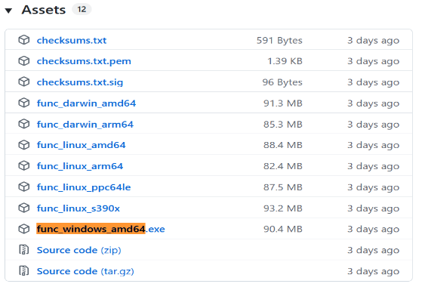
Download the file and rename it to "func.exe". Then place it in D:\func\func.exe. Add it to the system PATH. Verify whether the CLI is functioning properly:
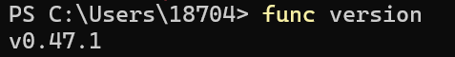

1.2 Creating a function
After we installed Knative Functions, we can create a function project by using the func CLI.
View all supported languages:
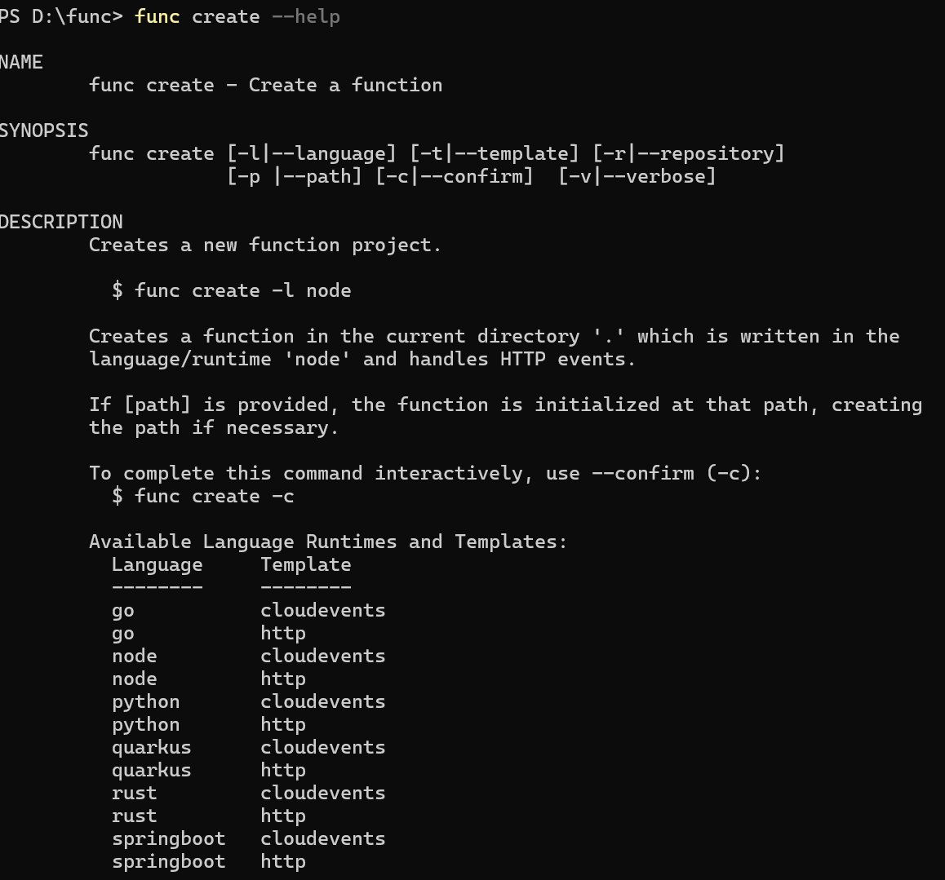
Create a Go function project named "hello".
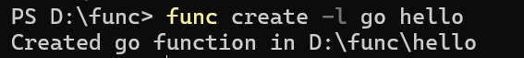

1.3 Building, running functions
Running a function creates an OCI container image for our function before running the function in our local environment, but does not deploy the function to a cluster.
Run the function locally by running the command in the project directory. Start by building the function in the local registry using the command:
func run [--registry <registry>]
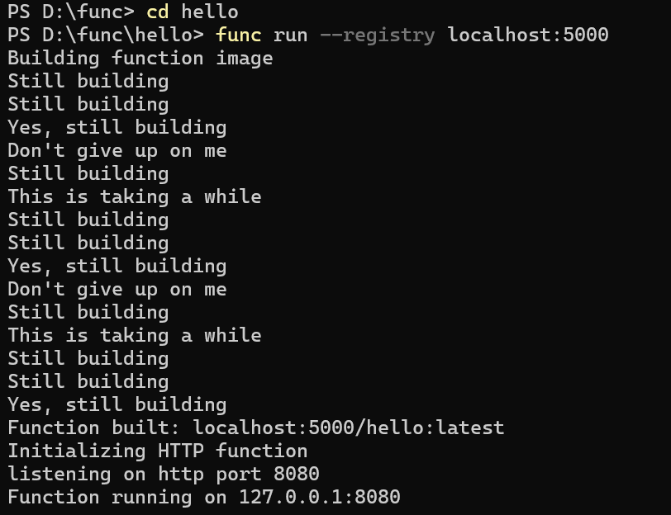
After building the image, run the container.
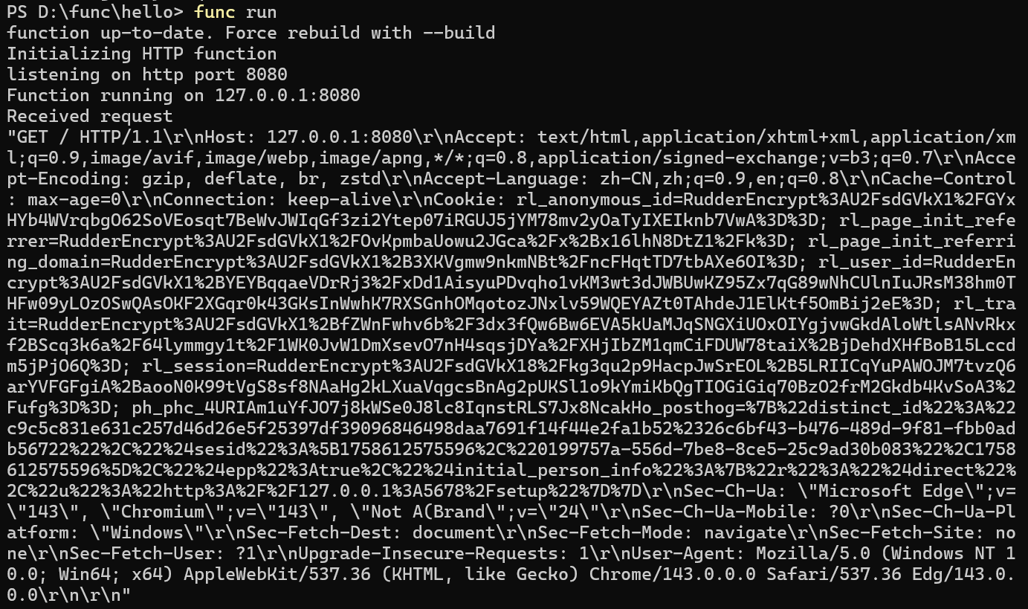

2. Deploying a Knative Service
We will deploy a "Hello world" Knative Service that accepts the environment variable TARGET and prints Hello ${TARGET}!.

2.1 Install kn CLI (Windows)
Download the kn Windows version kn-windows-amd64.exe and rename it to kn.exe and add it to the system environment PATH.
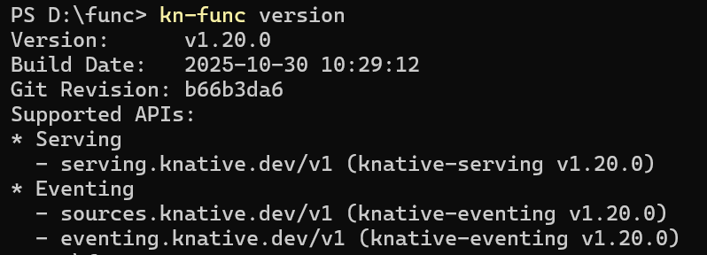
Similarly, install the Knative quickstart plugin: quickstart.
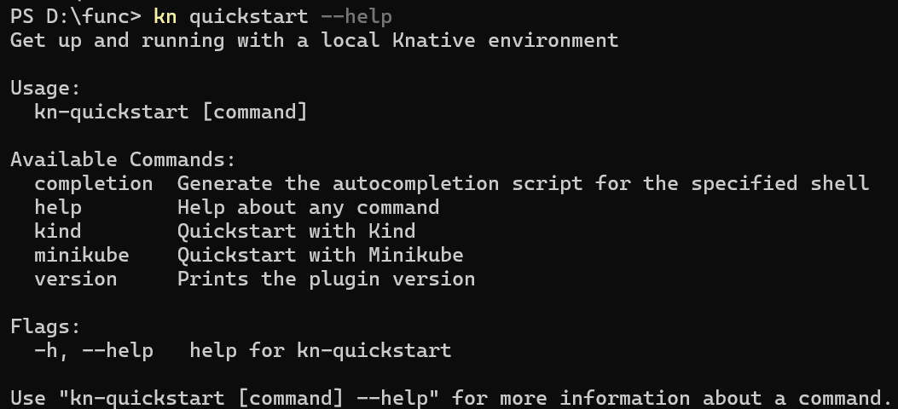
To get a local deployment of Knative, run the quickstart plugin. Install Knative and Kubernetes in a minikube instance by running.
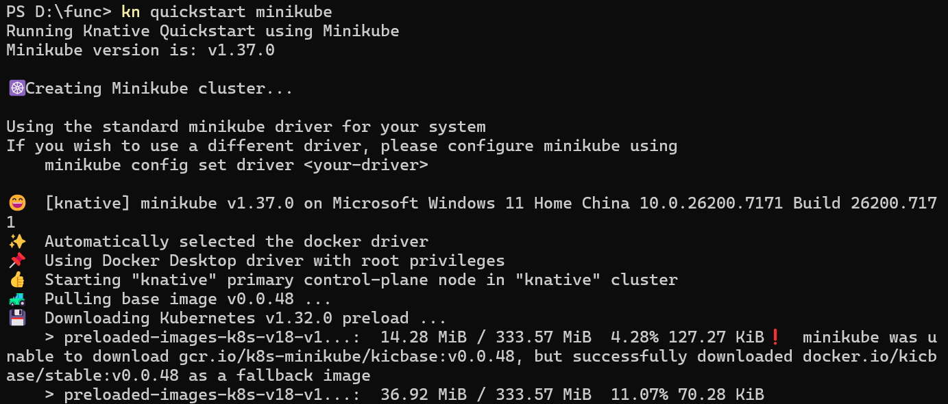
Deploy the Service by running the command:
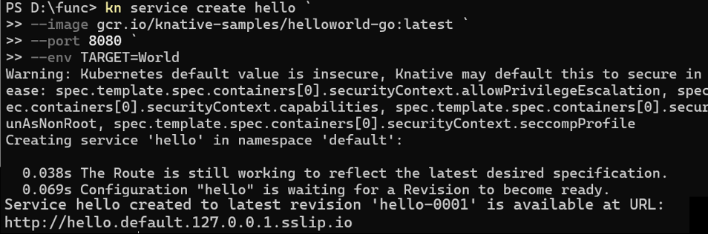

2.2 Autoscaling
Knative Serving provides automatic scaling, also known as autoscaling. This means that a Knative Service by default scales down to zero running pods when it is not in use.
Use the Knative (kn) CLI to view the URL whereour Knative Service is hosted. View a list of Knative Services by running the command:
Access our Knative Service by opening the previous URL in our browser or by running the command:
Watch the pods and see how they scale to zero after traffic stops going to the URL. It may take up to 2 minutes for our pods to scale down.
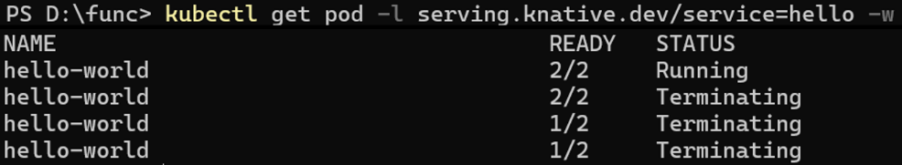

2.3 Traffic splitting
Instead of TARGET=World, update the environment variable TARGET on your Knative Service to greet "Knative" instead.
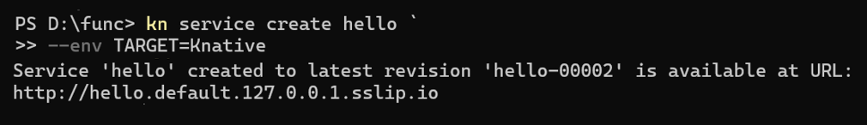
We can view a list of existing Revisions by using the Knative (kn) or kubectl CLI:
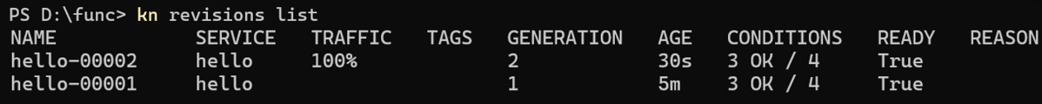
Split the traffic between the two Revisions:
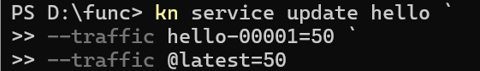
Verify that the traffic split has configured correctly, list the Revisions again by running the command
We can access the Service URL from the terminal multiple times to see the traffic being split between the Revisions.
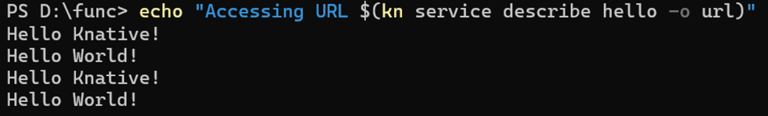

3. Knative Eventing
Knative Eventing provides us with helpful tools that can be used to create event-driven applications, by easily attaching event sources, triggers, and other options to our Knative Services.

3.1 Sources, Brokers, and Triggers
As part of the kn quickstart install, an InMemoryChannel-backed Broker is installed on our kind cluster. Verify that the Broker is installed by running the following command:

3.2 Using a Knative Service as a source
In this tutorial, we will use the CloudEvents Player app to showcase the core concepts of Knative Eventing. We should have an architecture that looks like this:
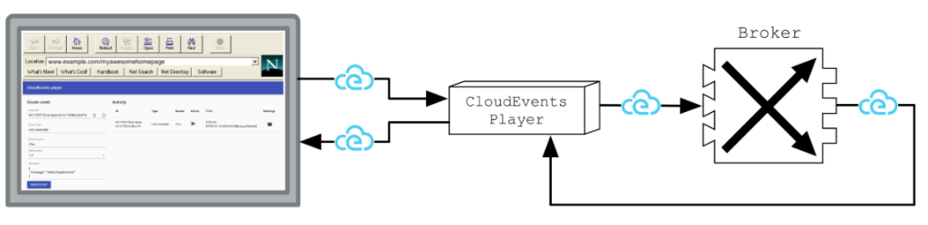
First, create the CloudEvents Player Service:
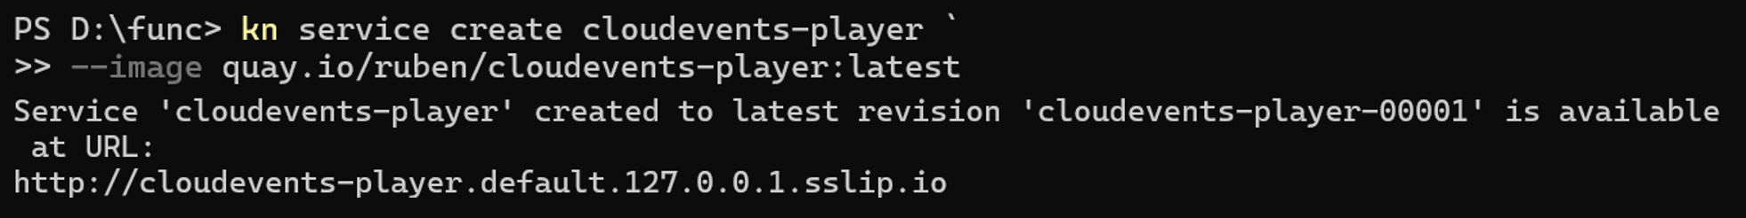
The service is now running but it doesn't know where the broker is so let's create a SinkBinding between the service and the broker.
Then, we can use the CloudEvents Player to send and receive CloudEvents. If e open the Service URL in your browser, the Create Event form appears. The Service URL is http://cloudevents-player.default.127.0.0.1.sslip.io.
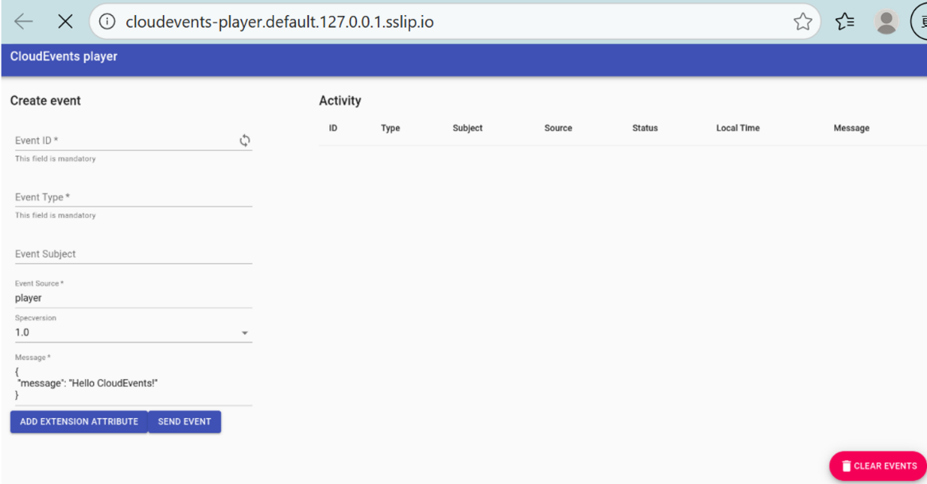
Try sending an event using the CloudEvents Player interface:
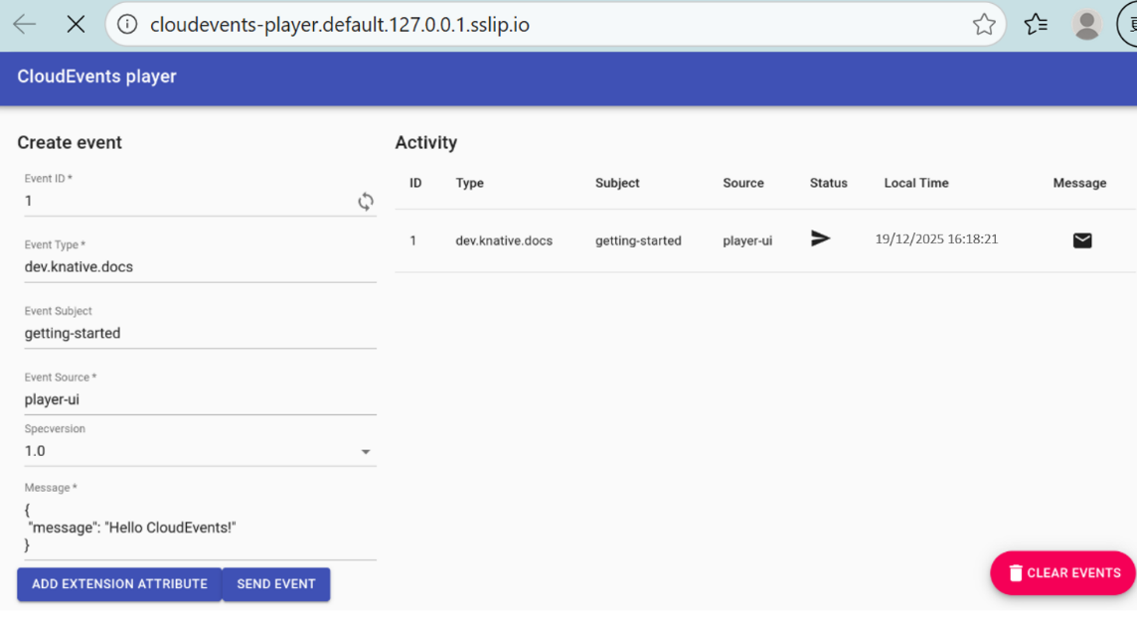

3.3 Using Triggers and sinks
Create a Trigger that listens for CloudEvents from the event source and places them into the sink, which is also the CloudEvents Player app.
Now, when we go back to the CloudEvents Player and send an event, we see that CloudEvents are both sent and received by the CloudEvents Player:
